**U.S.T.H.B /C.E.I.L 2020 /2021**

**Computer Science Department Master 1**

**Second-Term English Exam**

**Part 1**

Full name: Youcef Madadi Section: MIV

Registration N°: 171731094320 Group: 2

***Writing***

**✍** The graph below shows the worldwide Top 4 PC companies’ sales over a period of

time. Summarize the information in the graph by selecting and reporting the main

features. Make comparison where relevant.

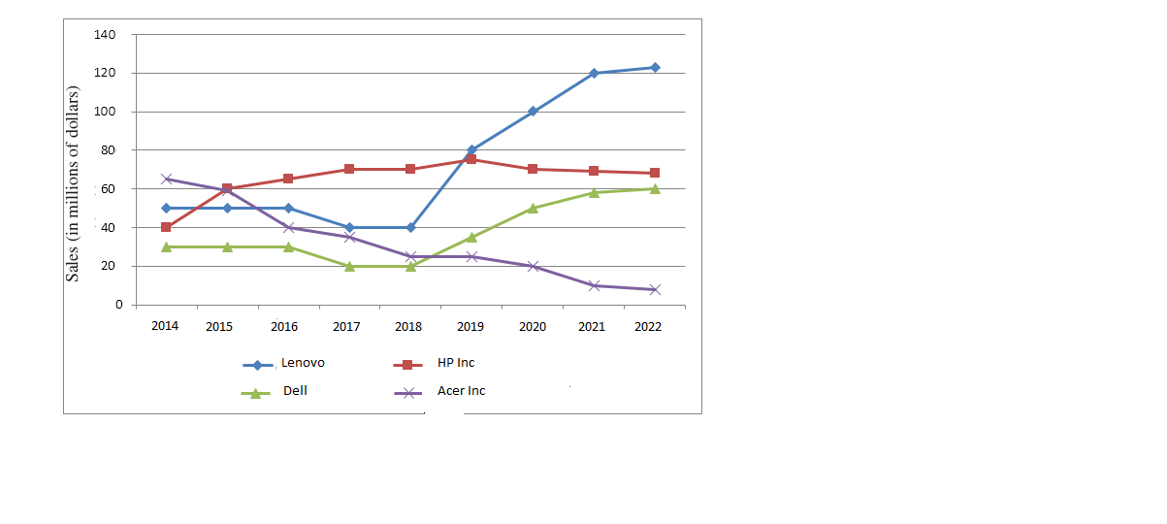Note: This graph is designed for writing practice only. Information in the graph is not accurate.

The graph shows the worldwide Top 4 PC companies’ sales over 8 years period from 2014 to 2022). The graph is given as sales in millions of dollars for the four companies (Lenovo, HP Inc, Dell and Acer Inc.

Overall, there was a great competition in the sales between the four companies. Their sales were close to each other especially in the first 5 years their sales were between 20 and 70 million dollar each with stable changes, and some dramatical changes after those 5 years form some companies.

We notice that there is a fall to one-sixth in the sales for Acer Inc from 2014 to 2022, meanwhile Lenovo and Dell faced its own changes similarly during the period where it kept consistent number of sales until it did fall slightly from 2016 to 2018, then we can notice the sudden change where it started growing rapidly to triple the sales of 2018 about 120 million dollars for Lenovo and ranked the first for the last 3 years and about 60 million for Dell. HP Inc climbed the sales steadily beating up Acer Inc in 2015 and peaked in 2019 where it’s been taken by Lenovo but kept high sales.

We conclude that Lenovo and Dell sale are increased sharply during this period of time meanwhile HP kept a steady growth. And in the other hand we saw the great of ACER.